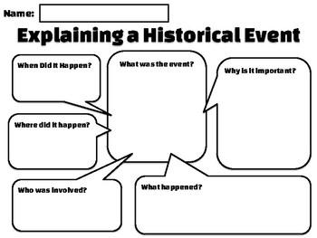

Name:___________________ GRAPES Chart

Event: _______________________________________ Culture/Civilization:___________________________________

Date/Time Span:____________________

| Geography   * Location * Physical * Movement * Human/Environment * Region |  |
| --- | --- |
| Religion   * Holy Books * Beliefs, Teachings * Conversion * Sin/Salvation * Deities |  |
| Academics, Advancements   * Art, Music * Writing, Literature * Philosophy * Math & Science * Education |  |
| Political Climate   * Leaders, Elites * State Structure * War * Diplomacy, Treaties * Courts, Laws |  |
| Economic Climate   * Type of System * Technology, Industry * Trade, Commerce * Capital/Money * Types of Businesses |  |
| Social Climate   * Family * Gender Relations * Social Classes * Inequalities * Life Styles |  |
| Empathy/Relatability   * How would you feel if you were present at this event? * How would you react to this event emotionally? * How would you move past this event, emotionally and mentally? |  |